**POP DENSITY**

SELECT n.area_name, n.population/n.land_area AS "population_density"

FROM neighbourhoods n JOIN sa2_2016_aust sa2 ON(n.area_name = sa2.sa2_name16)

WHERE LOWER(sa2.gcc_name16) LIKE '%sydney%'

**DWELLING DENSITY**

SELECT area_name, number_of_dwellings/land_area AS "dwelling_density"

FROM neighbourhoods n JOIN sa2_2016_aust sa2 ON(n.area_name = sa2.sa2_name16)

WHERE LOWER(sa2.gcc_name16) LIKE '%sydney%'

**BUSINESS DENSITY**

SELECT area_name, number_of_businesses/land_area AS "business_density"

FROM neighbourhoods n JOIN sa2_2016_aust sa2 ON(n.area_name = sa2.sa2_name16)

WHERE LOWER(sa2.gcc_name16) LIKE '%sydney%'

**ASSISTIVE SERVICE DENSITY**

SELECT n.area_name, b.health_care_and_social_assistance/n.land_area AS "assistive_service_density"

FROM businessstats b JOIN neighbourhoods n USING(area_name) JOIN sa2_2016_aust sa2 ON(n.area_name = sa2.sa2_name16)

WHERE LOWER(sa2.gcc_name16) LIKE '%sydney%'

**SUBURB HILLINESS**

SELECT sa2.sa2_name16 AS "suburb", COUNT(relativeheight) AS "height_entries"

FROM spotheight s FULL OUTER JOIN sa2_2016_aust sa2 ON ST_Contains(sa2.geom, s.geom)

WHERE LOWER(sa2.gcc_name16) LIKE '%sydney%'

GROUP BY suburb

SELECT sa2.sa2_name16 AS "suburb", MAX(s.relativeheight) - MIN(relativeheight) AS "hilliness"

FROM spotheight s JOIN sa2_2016_aust sa2 ON ST_Contains(sa2.geom, s.geom)

WHERE LOWER(sa2.gcc_name16) LIKE '%sydney%'

GROUP BY suburb

**AVERAGE SUBURB BFPL RISK AND BFPL PER SUBURB**

SELECT sa2.sa2_name16 AS "suburb", AVG(rfs.category) AS "average_risk_category", (rfs.shape_area/n.land_area) AS "BFPL_per_suburb"

FROM rfsnswbfpl rfs, sa2_2016_aust sa2 JOIN neighbourhoods n ON(sa2.sa2_name16=n.area_name)

WHERE ST_Contains(sa2.geom, rfs.geom)

AND LOWER(sa2.gcc_name16) LIKE '%sydney%'

GROUP BY sa2.sa2_name16, rfs.category, (rfs.shape_area/n.land_area)

**NEIGHBOURHOOD AFFLUENCE BY MEDIAN INCOME, AVG RENT**

SELECT n.area_name AS "suburb", n.median_annual_household_income AS "median_income_p.a.", n.avg_monthly_rent

FROM neighbourhoods n JOIN sa2_2016_aust sa2 ON(n.area_name=sa2.sa2_name16)

WHERE LOWER(sa2.gcc_name16) LIKE '%sydney%'

**SA1, SA2, SPOTHEIGHT JOIN RESTRICTED TO BLUE MOUNTAINS**

SELECT sa1.sa2_name16 AS "suburb", sa1.geom AS "sa1Geoms", sa2.geom AS "sa2Geoms", s.geom AS "spotheightGeoms", s.relativeheight

FROM sa1_2016_aust sa1 JOIN sa2_2016_aust sa2 USING(sa2_name16) JOIN spotheight s ON ST_Contains(sa1.geom, s.geom)

WHERE LOWER(sa2.sa2_name16) LIKE '%blue mountain%'

**Converting geom datatype to WKT**

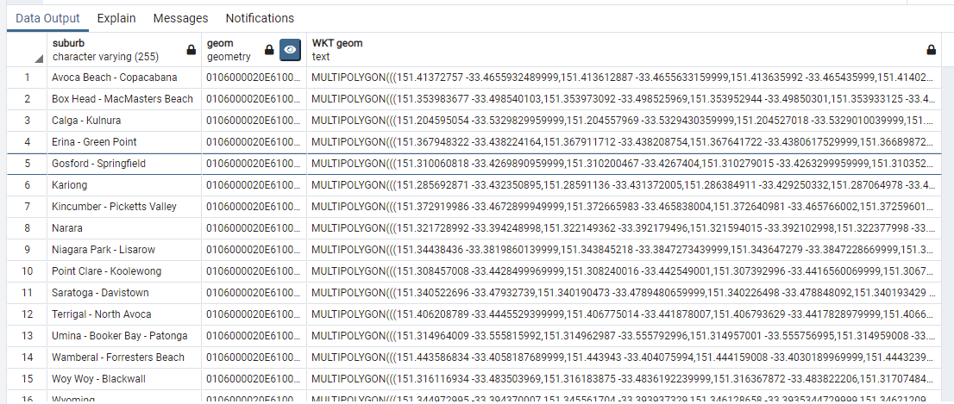

SELECT sa2_name16 AS "suburb", geom, ST_AsText(geom) AS "WKT geom"

FROM sa2_2016_aust

WHERE LOWER(gcc_name16) LIKE '%sydney%'

**New blue mtns join incl neighbouring areas**

SELECT sa1.sa2_name16 AS "suburb", sa1.geom AS "sa1Geoms", sa2.geom AS "sa2Geoms", s.geom AS "spotheightGeoms", s.relativeheight

FROM sa1_2016_aust sa1 JOIN sa2_2016_aust sa2 USING(sa2_name16) JOIN spotheight s ON ST_Contains(sa1.geom, s.geom)

WHERE LOWER(sa2.sa2_name16) IN (SELECT LOWER(sa2dup.sa2_name16)

FROM sa2_2016_aust sa2main JOIN sa2_2016_aust sa2dup ON (ST_Intersects(sa2main.geom, sa2dup.geom))

WHERE LOWER(sa2main.sa2_name16) LIKE '%blue mountain%')

